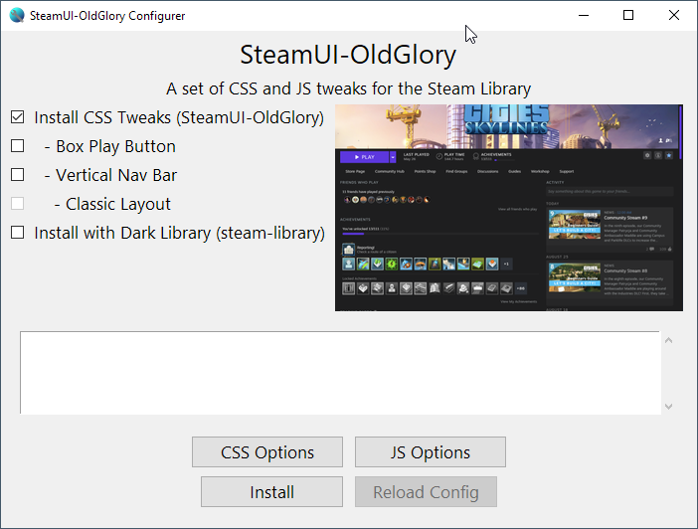

**General Automation**

Get Steam (steamui) directory

Copy files over

For enabling/disabling CSS

Finding comment headers

Adding /* or */ on same line

Error check if not existing

Run from executable directory

Subdirectory for css/js files

Copy only necessary files

Is this confusing?

**What goes into oldglory.py and backend.py?**

old_glory.py contains functions that generate and interact with the UI, as well as the “first level” of functions that process input values from the GUI (eg: Checkbutton values, and validation for these Checkbuttons)

backend.py deals with functions that load config and modify files

js_tweaker.py contains functions that modify the Steam JavaScript files. It can also be run standalone, similar to how old versions of js_tweaker.py work

**Install CSS Tweaks**

Copy over libraryroot.custom.css

**Box Play Button**

if CSS not already uncommented out

Uncomment Box Play Button CSS

Error detection if cannot find comment header

**Vertical Nav Button only**

if CSS not already uncommented out

Uncomment Box Play Button CSS

Error detection if cannot find comment header

**Classic Layout only**

Vertical Nav Bar must be selected as well

if CSS not already uncommented out

Uncomment Box Play Button CSS

Error detection if cannot find comment header

**Library Theme (steam-library)**

Drop down selector for theme

Show preview image

On install, check whether theme code needs to go “before” or “after” the CSS tweaks, and act accordingly.

**Reload Config**

Main uses:

Reread from libraryroot.custom.css to update CSS options page

Reread from fixes.txt to update JS Options page

Run js_tweaker or similar

1 button for all these purposes seems too much, yet having too many buttons complicates things

**Config File Format (backend)**

**CSS Options Page**

Backend:

load from libraryroot.custom.css :root section or default config, the CSS Variables as options

find start and end sections in the CSS file

error checking if missing, redirect to default config

Format is nested dictionary:

Property Group: {

Property Name: {default value, current value, options {a, b, c}, desc}

}

Frontend: Ttk Combobox entry + dropdown

Generated from backend’s loaded CSS options

Add in python testing?

Some tests added (but then commented out because the code changed)

General Maintenance

When Steam updates with a new version of JavaScript, all the minified variable names get changed.

Biggest source of maintenance, last update (Oct 8), half the JS tweaks had to change their variable names to work again

Can automate the process by wildcarding variable names?

Fortunately this doesn’t happen often enough, that automating is a necessity to avoid insanity.

Nothing gets broken, just that JavaScript tweaks stop working.

So the more JS tweaks I add, the bigger potential breakdown and loss in added functionality provided by my tweaks

Partial solution found using Regex replacing instead of straight up find and replace.

Not fully implemented

**v0.7 Requirements left stage**

done = currently implemented

todo1 = needed for beta 1.0 patch to be released

todo2 = can be done later, but ideally done with todo1

todo3 = extension functionality to be done after todo2

**On Program Startup**

(done) Load CSS config preset values from libraryroot.custom.css :root {

(done) Load JS fixes preset values from fixes.txt

**On CSS Options Button Click**

(done) Populate GUI with selected radio buttons based on values in file

(todo1) Populate GUI with selected radio buttons based on modified values (since start)

(todo2) Show if a custom value is selected

(todo2) what that value is

(todo2) programmatically create radio button groups

**On JS Options Button Click**

(done) Populate GUI with selected Checkbuttons based on values in file

(done) Populate GUI with selected Checkbuttons based on modified values (since start)

**On Install Click**

(todo1) get current modified CSS and JS config values

(done) **set css and js modified according to checkboxes**

(todo2) programmatically create these for easier maintainability in the future

On Reload Config

(todo1) update GUIs with values from file, overwrite modified values

General

(todo1) Stop confusing yourself

**v0.8**

(done) modify JS file/run_js_tweaker if JS Options (GUI) have been changed

Trigger on any click of checkbox in JS Options

Slightly more ideal would be to equate js settings dictionary

(done) write code to add in library themes (Shiina’s and spikedballofdoom’s)

(todo3) make the code easily maintainable as I add in features (can be hard to do)

File directory changes

Write

Copy_files_from_steam

Copy_files_to_steam

Add flag variable to not run these functions unless told to do so

**v0.9 (v0.8.90)**

Left to do

(done) Dark library theme installation

(todo2) DLC Manager CSS “comment out”

(done) CSS Options not applying?

(done) copy libraryroot.css over if just CSS (use backend)

(todo2) do extensive testing, use cases

(done) redo vertical nav bar root css variables I just lost (oof)

(done) clean reset window/button

Version number, by Jonius7

run functions with reset=1 argument

(todo2) Prompt for and download SteamFriendsPatcher automatically

**v0.98 (v0.8.98)**

Left to do

(todo2) Make “Reload Config” actually apply across all areas (not just JS)

Reload from oldglory_config.cfg (set checkboxes)

Reload from libraryroot.custom.css

(done) Select correct radio button for CSS on startup

(todo2) Rewrite it for easier expansion/modularity

(done?) clean up some print output  
 (done) clean reset window/button

(done) Version number, by Jonius7

(done) run functions with reset=1 argument

v0.98 renamed to v0.8.98

v0.9.4 Beta (first release with SteamUI-OldGlory 4.0)

(todo1) BUG: Clicking reset button library.js not found

(fixed) No such file or directory library.js

Where can I put custom library css code

libraryroot.custom.css

config.css is not created, instead it is created from config.css.original (is that confusing?)

CSS bug 1: black background not extending all the way down

(done): extended to 2000px down

CSS request: option to configure left or right column

(done) also fixed community feed 100% width

CSS bug: community feed not 100% width

(done) Fixed! Very simple

V0.9.4.3 Beta

Added in Game Page Layout as default config in backend

**v0.95+**

Advanced Mode?

Show and hide certain buttons or switches

Config file

Easy to expand

Currently changes config.css values, which may be an annoyance if people want something other than HOME

Extract this out of the python into a JSON file? So I don’t have to “recompile” exe if I want to change it?

Extract certain Python dictionaries into .json files.

So I don’t have to “recompile” exe if I want to change these configurations.

Release 5.5 – 6 (GUI version 0.97+)

(todo1) CSS options – 2 tabs – **2nd tab is blank**

(done) Scrollable JS Options frame

(done) Style files updater

Changelog

Reload Config properly clears existing JS options

config.css

Now starts up quickly when user is offline (no internet connection detected)

Minor bug: status of scrollbar does not update on “Reload Config”